Coding Book of Dataset Preparation
Requirements of Annotated Task:
We use the FLAG3D dataset [1], which includes 180K videos spanning 60 daily fitness activities, comprising both raw real-world videos and motion capture data. Each activity is categorized by 10 body parts (chest, back, shoulder, arm, neck, abdomen, waist, hip, leg, whole body) and accompanied by detailed, professional sentence-level instructions.
Since fitness activities targeting the same body part share similarities, we select one representative movement from each category. Working closely with four domain experts (E1-4), we manually process the data in three steps: 1) Identify key poses based on motion capture data and videos. For each motion, we determine key attributes (e.g., hip trajectory in a sumo squat) and visualize them to detect extreme points as key poses, followed by the first round expert verification. 2) Align key pose segmentation with language instructions. Missing instructions are supplemented through expert consensus. 3) Extract initial kinematic constraints from the instructions for each key pose. After ensuring that all experts have a correct understanding of kinematic constraints, they independently review and define constraints based on the instructions. Each expert annotated five fitness activities categorized by body part and verified another five annotated by peers. A cross-check process ensured accuracy and completeness, with disagreements resolved through open-meeting discussions.
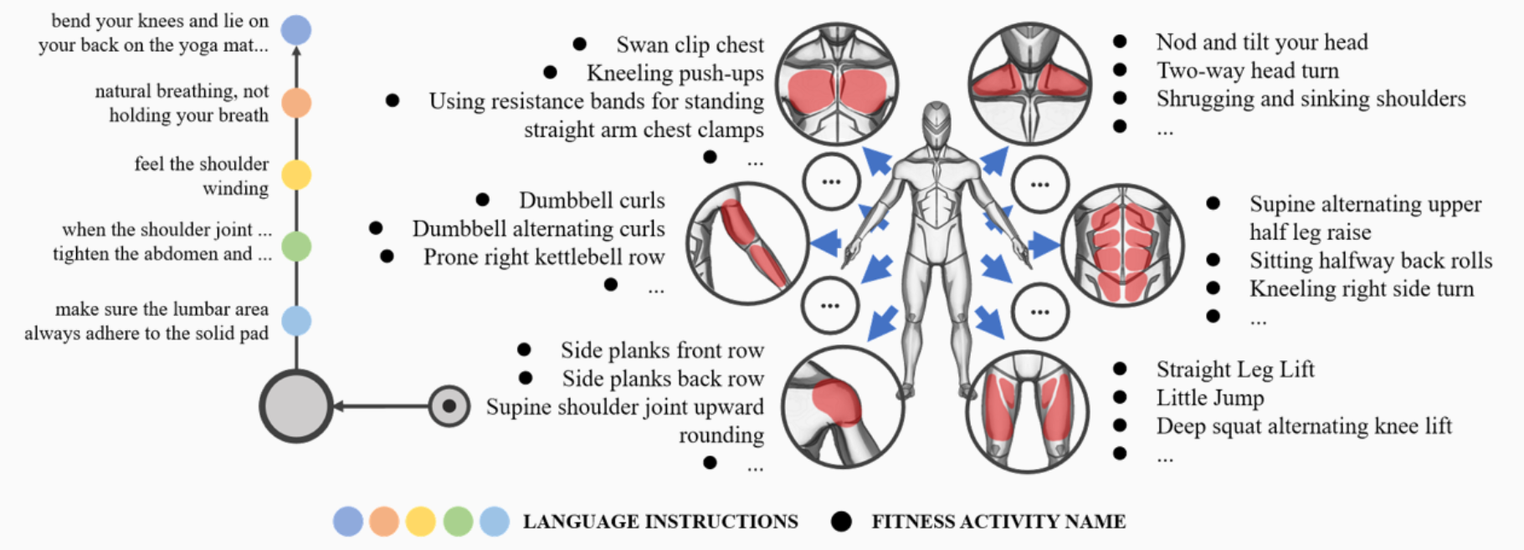
FLAG3D[1] is a 3D fitness activity dataset composed of the following parts:
• SMPL
• Skeleton
• Language
• Video from Nature Scene
• Rendering Video (subset): We share a subset of it which contains 1800 videos because of the data size. If you needs more, please email us.
• Raw Data: Raw data from MoCap software. You can work with it in rendering software like Unity.

Annotation Entry Value Definition:
Overview:
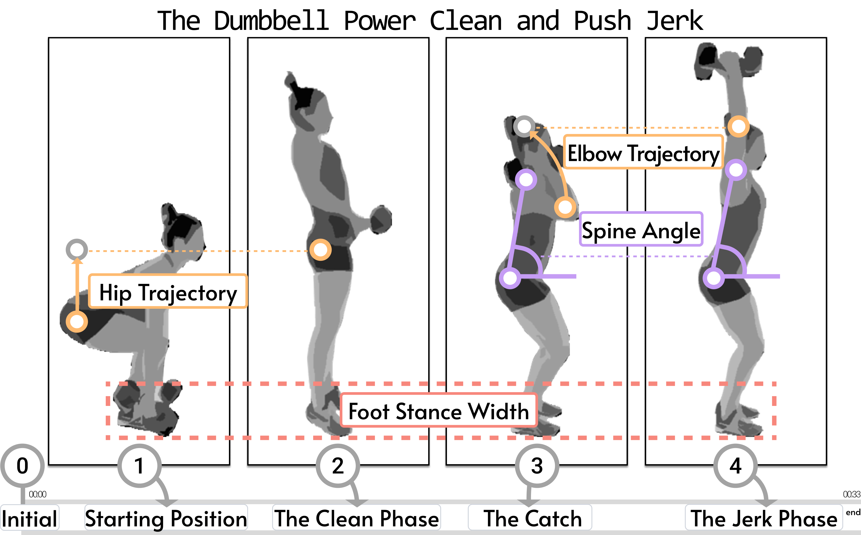
Key Pose:
- Key poses are a set of representative poses that concisely capture the essential structure of a full-body movement. (mark as key frame here)

Key Attribute:
- The term "key attributes" in the context of fitness refers to the essential characteristics that define a specific exercise, particularly focusing on a particular body part. For example, in a sumo squat, the hip trajectory is a key attribute. These attributes describe the primary joint movements and the target muscles involved in the exercise.
- E.g.:
  - Joint Variables
    - Hip Movement: In a sumo squat, the hips move through a significant range of motion, involving both flexion and extension. The wider stance and turned-out foot position require greater external rotation of the hip joint, which enhances hip mobility
  - Target Muscles
    - Glutes: The gluteal muscles, including the gluteus maximus, medius, and minimus, are heavily engaged during a sumo squat. The gluteus maximus is particularly important for generating power during the upward phase

Kinematic Constraints:
- Augular: Angular constraints represent the orientation of a body segment or line relative to a reference joint. These constraints are defined by a triplet representing the first side endpoint, the vertex, and the second side endpoint. The vertex is a joint, and the endpoints can be both joints or a joint and an axis.
  - Angle describe the bending of a body part, defined by three key joints (e.g., the angle between the upper arm and torso is formed by the elbow, shoulder, and hip).
  - Pitch & Roll describe the verticality or horizontality of a body part, defined by two key joints and a relative axis (e.g., the neck and hip, along with the hip's z-axis, define the spine's bend angle).
- Positional: Positional constraints represent the distance and relative position of two key joints. These constraints are defined by a pair of endpoints or their projections on a specific axis. Additionally, the ground is treated as a special point to calculate the height.
  - Distance describes the L2-distance between two key joints (e.g., the distance between the hip and the ground defines hip height, or the distance between the left and right ankles defines feet distance).
  - Relative Position describes the difference between the projections of two key points along a given axis, defined by the two key joints and their reference axis (e.g., the projections of the right wrist and right ankle on the x-axis define which is more inside).
- Temporal: The aforementioned attributes describe constraints for fixed static poses. In contrast, temporal constraints represent dynamic changes (position, direction, velocity) in transitional poses. These constraints are defined by sets of key joints.
  - Trajectory describes the spatio-temporal position of joints, encompassing velocity and direction (e.g., the lifting trajectory of the feet can be defined by tracking the ankles).
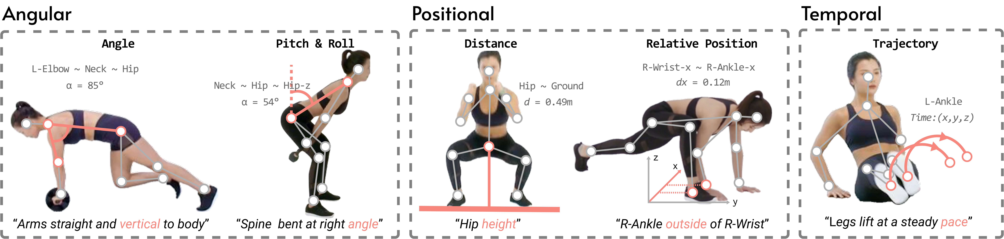

Language Instructions:
- Detailed and professional language instruction to describe how to perform a specific activity.
This figure details a concrete example of the “Squat With Alternate Knee Lift” activity that is mainly driven by the quadriceps femoris muscle of the “Leg”, while the corresponding language instructions are shown in the left.

Ground Truth Feedback:
- To validate the effectiveness of the constraint filter module during inference, we selected three fitness activities from our dataset: sumo squat, push-ups, and jumping jacks. These activities represent lower-body, upper-body, and full-body movements, respectively. For each activity, we annotated key pose errors in 30 samples, with ground truth feedback provided by coaches. They were asked to examine the motions and selected corresponding aligned language instructions from our dataset. We segmented the generated text and ground truth into individual sentences, pairing them for comparison.
Action Class:
- Selected activities exercise most parts of our body, including the chest, back, shoulder, arm, neck, abdomen, waist, hip, leg, and whole body.
- (https://andytang15.github.io/FLAG3D/figure/class.pdf)

Annotation Guidelines:
1) Identify key poses based on motion capture data and videos. For each motion, we determine key attributes (e.g., hip trajectory in a sumo squat) and visualize them to detect extreme points as key poses, followed by the first round expert verification.
2) Align key pose segmentation with language instructions. Missing instructions are supplemented through expert consensus.
3) Extract initial kinematic constraints from the instructions for each key pose.

-------------------------------------------------V2(Mar.07)------------------------------------------------
Quality Control (Group Check):
We conducted repeated checks for annotation consistency to ensure the accuracy and uniformity of the annotated results. In the first round, we collected four sets of data for annotating 10 body parts videos, with four of them provided by sports coaches we collaborated with. During the process of dataset preparation, inconsistencies arose in the feedback generated by each individual. To address this, we initiated a group check discussion, providing explanations for each perspective, and ultimately integrated them into the final set of feedback for each key pose clip.
For the rest of the annotations, we employed a method of iterative annotation checks to rectify annotation errors.

We have preserved each version of the coding book along with the annotated data.
Details in the folder: dataset.
Reference
[1] Yansong Tang, Jinpeng Liu, Aoyang Liu, Bin Yang, Wenxun Dai, Yongming Rao, Jiwen Lu, Jie Zhou, and Xiu Li. 2023. FLAG3D: A 3D Fitness Activity Dataset with Language Instruction. In 2023 IEEE/CVF Conference on Computer Vision andPattern Recognition (CVPR). 22106–22117. https://doi.org/10.1109/CVPR52729.2023.02117

